**The program is mainly focus on 2 parts: administrator and shop owners.**

**ADMINISTRATOR**

**Log in**

-Choose the radio button [管理员登录] if you are an administrator.

-Input your ID and passcode.

**[verify]**

- **Click [验证] to check the passcode from DB.**

If the verification fails , "×" will be displayed on the right end.

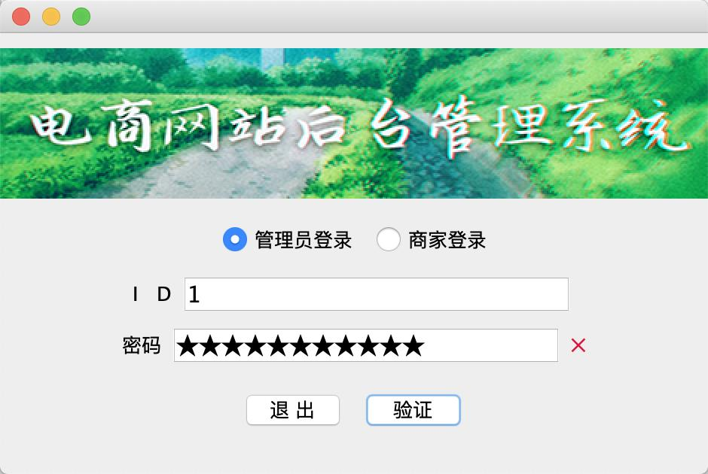

- **Click [验证] to check the passcode from DB.**

If the verification passes , "√" will be displayed on the right side, and the "verify" button will be changed to "ok" button to log in the account.

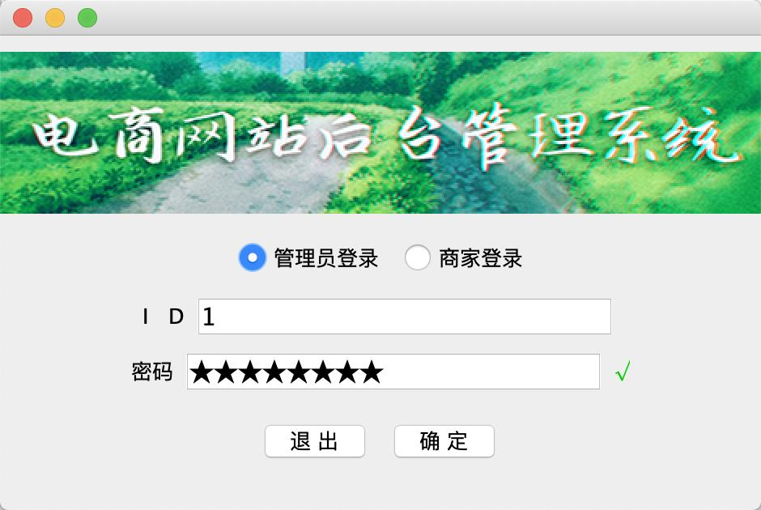

**Main Menu for administrator**

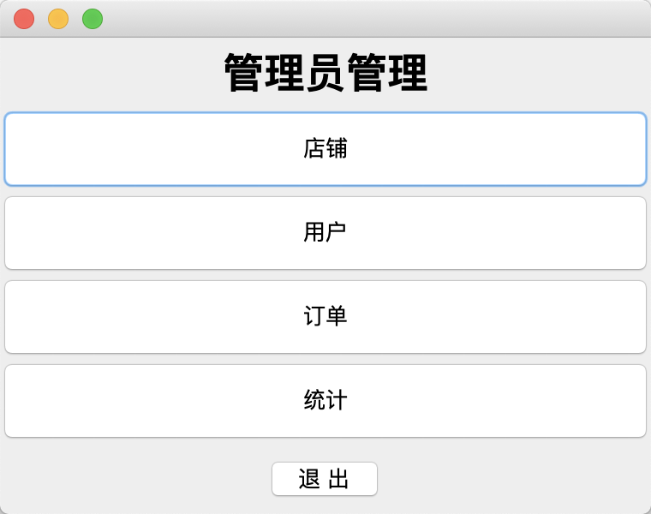

- Click [店铺] if you want to view by shop

- Click [用户] if you want to view by user

- Click [订单] if you want to view by order

- Click [统计] if you want to view by statistical data

**[shop] for administrator**

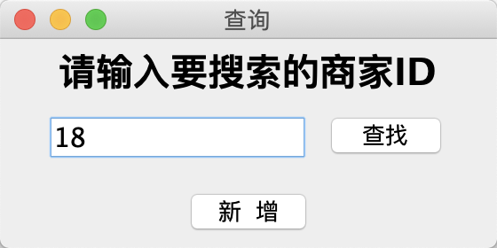

Search shops by shop ID ,and click[查找]

Search shops by clicking [新增]

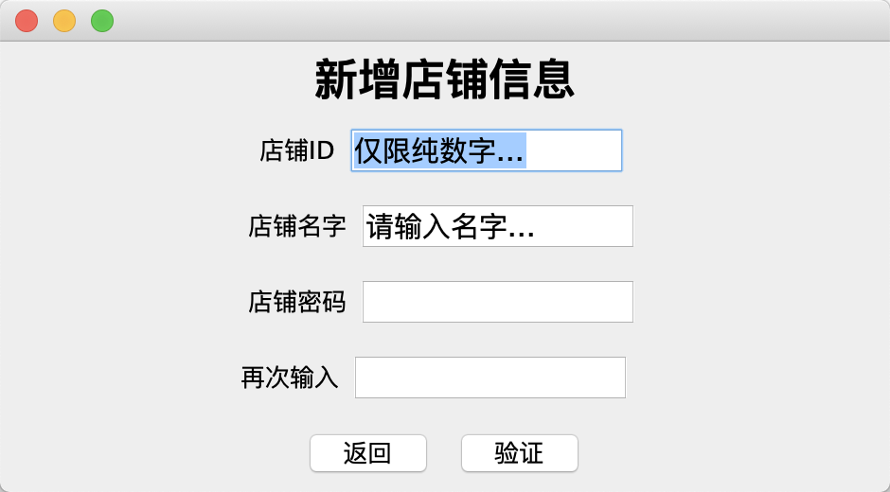

-Input the new shop ID in the 1st line.

-Input the new shop name in the 2nd line.

-Input the new shop password in the 3rd line.

-Input the new shop password again in the 4th line.

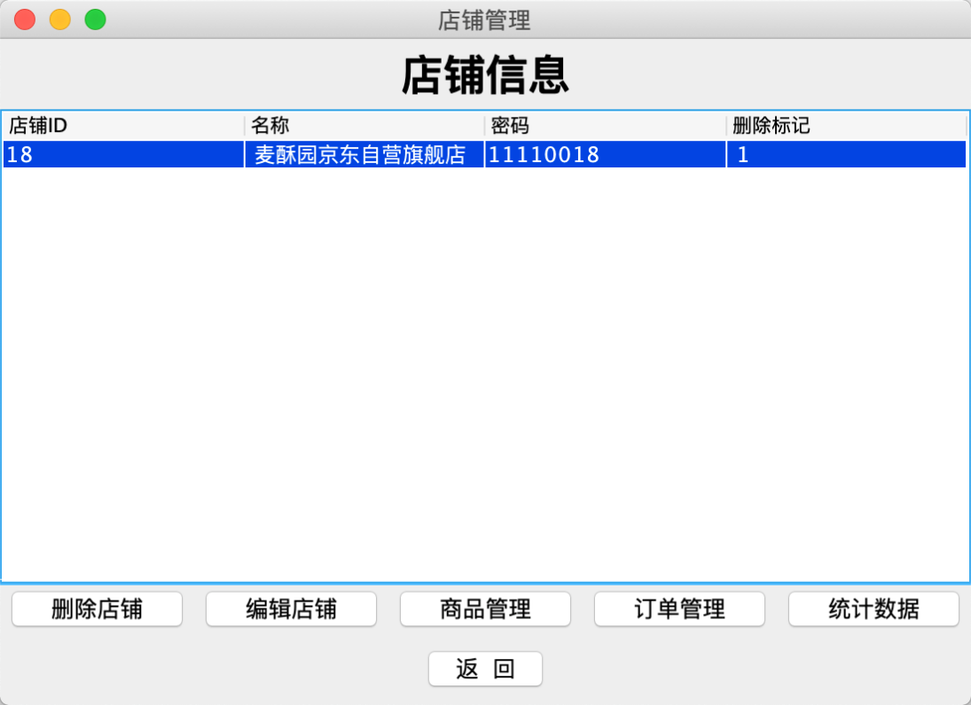

**- Click [删除店铺] if you want to delete shop**

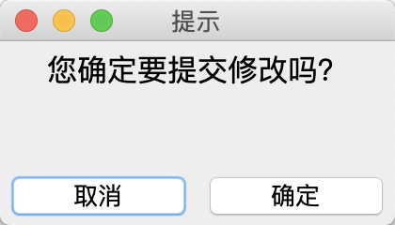

**- Click [编辑] if you want to edit shop**

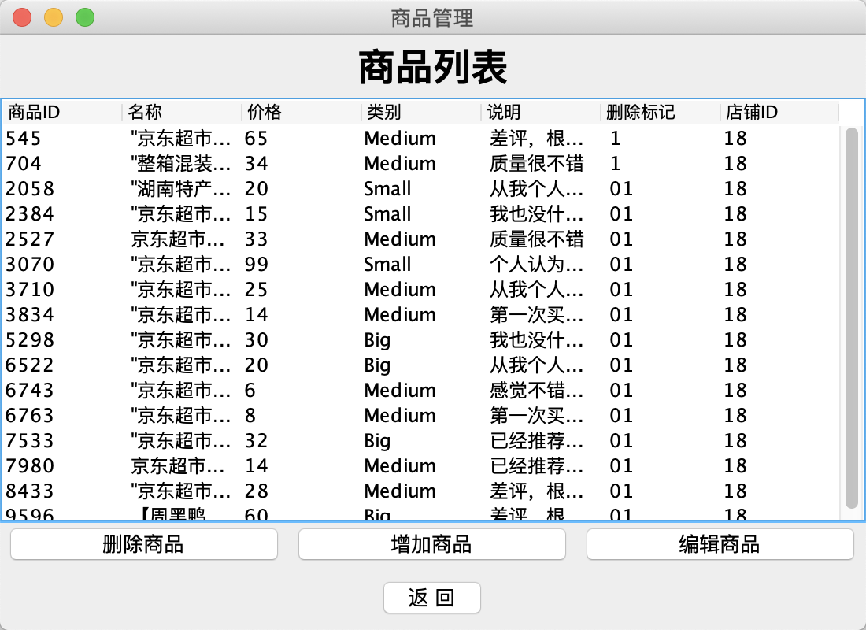

**- Click [商品管理] if you want to edit goods**

Commodity management interface includes three functions

– [delete] [add] [edit]

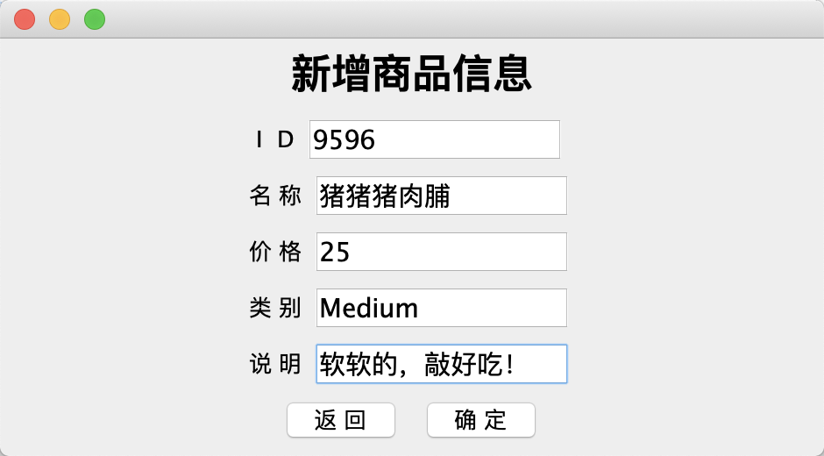

[add]- if you try to add the item that duplicate, database will prompt operation failure.

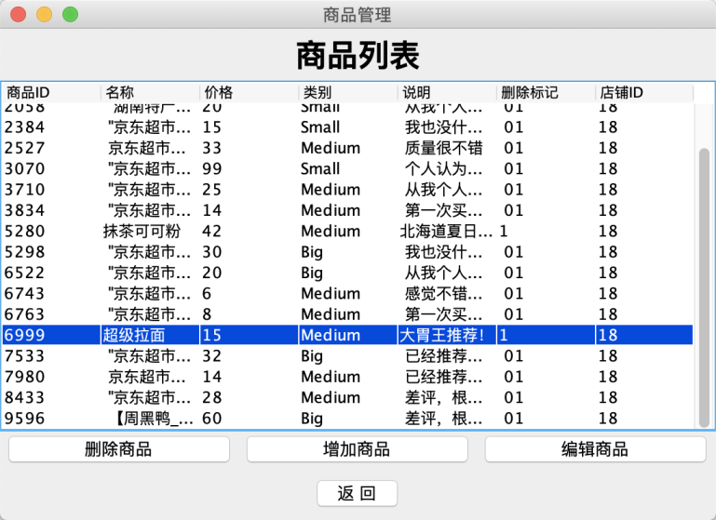

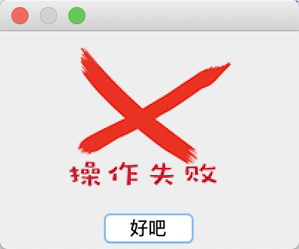

**- Click [订单管理] if you want to edit orders**

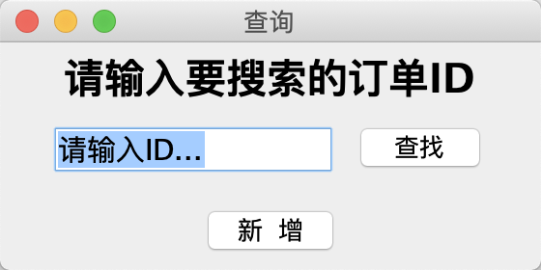You can [search] or [add order] by entering the order ID

You also can [delete] and [edit] the order.

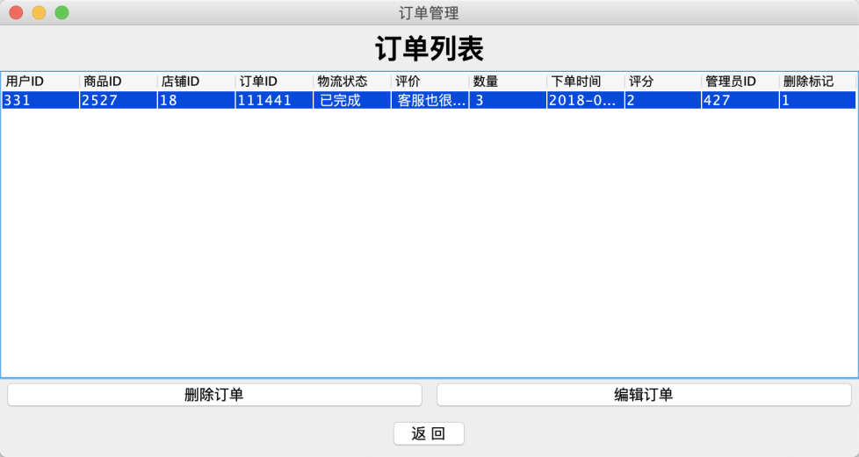

**- Click [统计数据] if you want to see the statistical data of this shop**

Statistics of all merchant data in the database

page13image51107968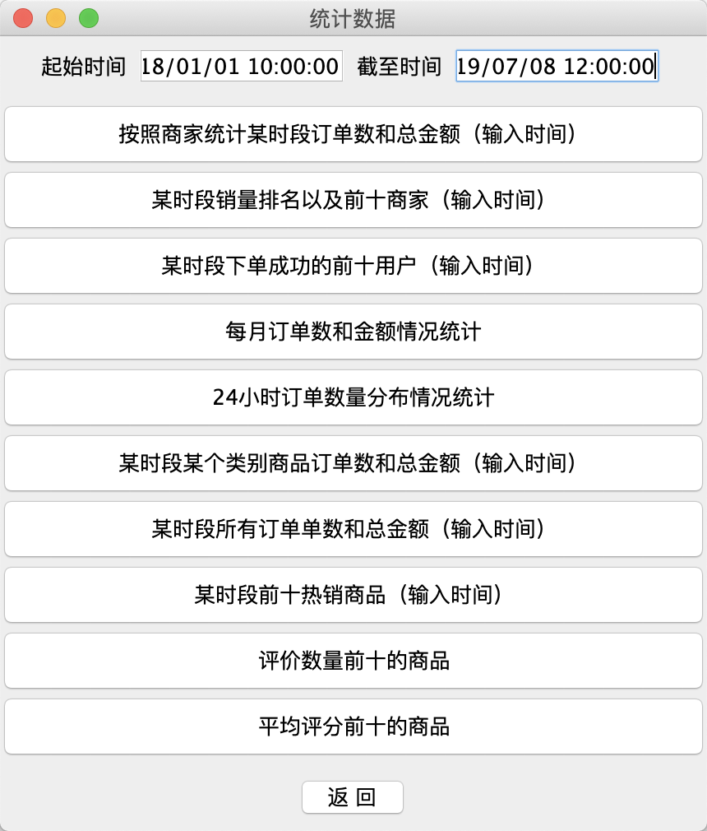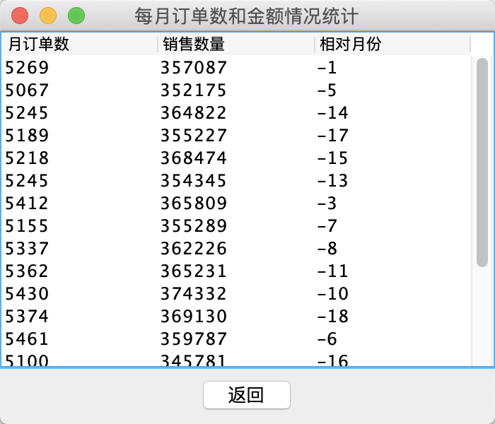

**[user] for administrator**

**[order] for administrator**

**[statistical data] for administrator**

**Return to the login interface -- [管理员登录] and enter the system as a merchant.**

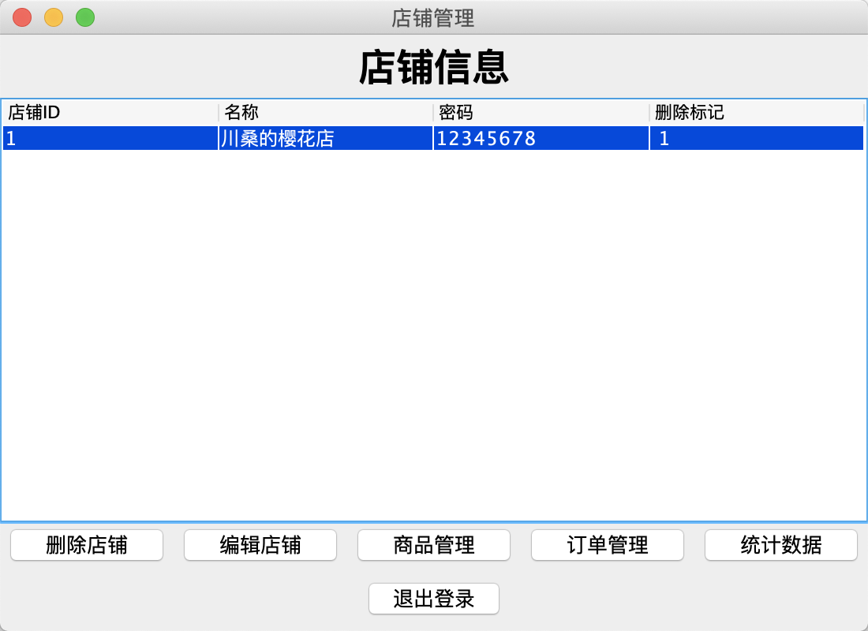

page13image51107968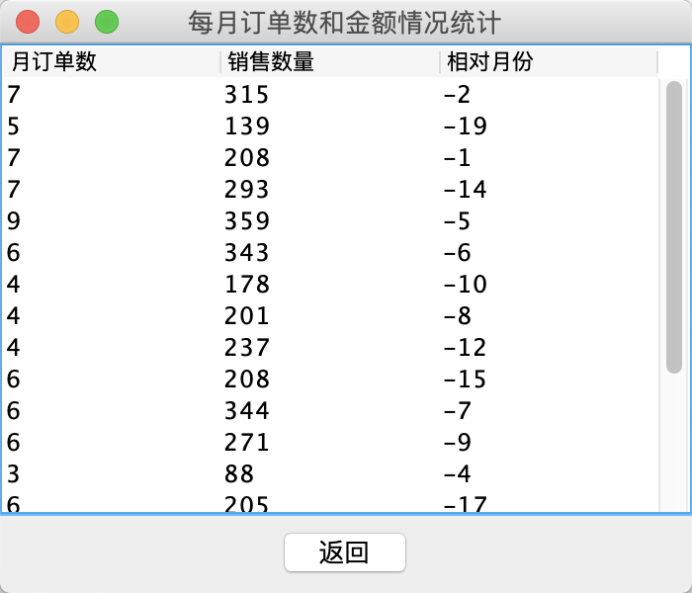

Most of the functions in the merchant system are basically consistent with the merchant functions of the administrator, but there are strict limits of authority, and only the data statistics of the store can be visited.

